Question 1:

#include<iostream>

using namespace std;

void kidWithCandies(int candies[], int candiesListSize, int extraCandies);

int main()

{

int candies[20], extra, size = 5;

cout << "Enter array: ";

for (int i = 0; i < size; i++)

{

cin >> candies[i];

}

cout << "Enter the amount of extra candies: ";

cin >> extra;

kidWithCandies(candies, size, extra);

system("pause");

return 0;

}

void kidWithCandies(int candies[], int candiesListSize, int extraCandies)

{

bool arr[20] = {false};

int max = 0;

for (int i = 0; i < candiesListSize; i++)

{

if (candies[max] < candies[i] )

{

max = i;

}

}

arr[max] = true;

for (int a = 0; a < candiesListSize; a++)

{

cout << arr[a] << " ";

}

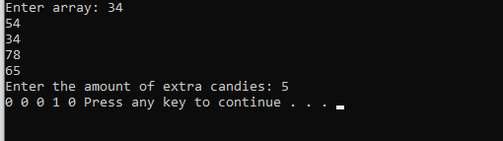

}

Question 2:

#include<iostream>

#include<stdlib.h>

#include<ctime>

using namespace std;

int main()

{

srand(time(0));

int arr[10] , j , key;

for(int i = 0 ; i < 10 ; i++)

{

arr[i] = rand() % 10 + 1;

}

for(int i = 0 ; i < 10 ; i++)

{

cout << arr[i] << " ";

}

cout << endl;

for(int i = 1 ; i < 10 ; i++)

{

key = arr[i];

j = i - 1;

while(j >= 0 && arr[j] > key)

{

arr[j+1] = arr[j];

arr[j] = -1;

j = j - 1;

}

}

for(int i = 0 ; i < 10 ; i++)

{

cout << arr[i] << " ";

}

return 0;

}

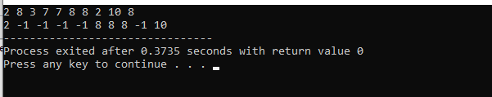

Question 3:

#include<iostream>

using namespace std;

bool result(int i , int j);

int main()

{

int const SIZE = 3 ;

int moves;

char arr[SIZE][SIZE];

char input;

cout << "Enter moves: ";

cin >> moves;

int i = 0 , j = 0;

cout << "Move the robot using r,l,u,d: ";

while(moves > 0)

{

cin >> input;

switch(input)

{

case 'r':

i++;

if(i == SIZE)

{

i = 0;

}

break;

case 'l':

i--;

if(i < 0)

{

i = SIZE-1;

}

break;

case 'u':

j--;

if(j < 0)

{

j = SIZE-1;

}

break;

case 'd':

j++;

if(j == SIZE)

{

j = 0;

}

break;

default:

cout << "WRONG INPUT";

}

moves--;

cout << "Moves Left: " << moves << endl;

}

if(result(i,j))

{

cout << "TRUE";

}

else

{

cout << "FALSE";

}

return 0;

}

bool result(int i , int j)

{

if(i == 0 && j == 0)

{

return true;

}

else

{

return false;

}

}

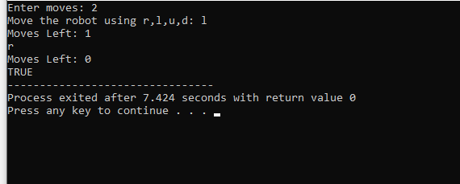

Question 4:

#include<iostream>

#include<fstream>

using namespace std;

int main()

{

ifstream in;

ofstream out;

in.open("input.txt");

out.open("output.txt");

int count , n , max = 0 , data;

while (!in.eof())

{

in >> data;

n = data;

while(n > 0)

{

in >> data;

count = data;

while(count > 0)

{

in >> data;

max = 0

if(data > max)

{

max = data;

}

count--;

}

cout << "Tallest student: " << max << endl;

n--;

}

}

return 0;

}

INPUT FILE Q4:

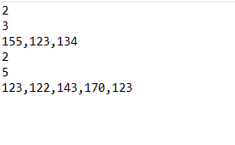

Question 5:

#include<iostream>

#include<cstring>

using namespace std;

int main()

{

char arr[100] , arr2[10];

cin.getline(arr,100);

cout << arr << endl;

int i = 0 , j = 0;

while(arr[i] != '\0')

{

if(arr[0] != 'a' || arr[0] != 'e' || arr[0] != 'i' || arr[0] != 'o' || arr[0] != 'u')

{

while(arr[j] != ' ')

{

cout << arr[j];

j++;

}

cout << "ma";

}

i++;

}

return 0;

}